
JD-19
YEAR 7 SCIENCE
EARTH & SPACE SCIENCES
TEST 1 - THE EARTH AND MOON

NAME: CLASS: MARK: $\frac{}{\text{35}}$

Multiple Choice Write the answer to each question in the appropriate box at right.

QUESTION | ANSWER
1
2
3
4
5
6
7
8
9
10
11
12
13
14
15
16
17
18
19
20
21
22
23
24
25
1. The main reason we have night and day on Earth is:

(a) Earth revolves around the Sun.
(b) Earth rotates on its axis.
(c) Earth orbits the Sun.
(d) Earth is tilted on its axis.

2. When Neil Armstrong stepped onto the Moon, he said:

(a) 'Gee I'm glad to be out of that cramped space capsule!'
(b) 'Come on Buzz, let's take a giant leap for mankind.'
(c) 'What a great achievement for Man, and indeed mankind.'
(d) 'That's one small step for Man, one giant leap for mankind.'

3. Refer to this diagram for the question below.

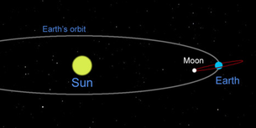

The diagram above shows:

(a) the Earth's path of revolution around the Sun.
(b) the Moon's rotation around the Earth.
(c) the Earth's rotation around the Sun.
(d) All of the above.

4. The Moon orbits the Earth once every 27.322 days. It also takes approximately 27 days for the Moon to rotate once on its axis. As a result, the Moon does not seem to be spinning but appears to observers from Earth to be keeping almost perfectly still.

(a) true
(b) false

5. Every day, the Sun appears to:

(a) rise in the east and set in the west.
(b) rise in the north and set in the south.
(c) rise in the west and set in the east.
(d) rise in the south and set in the north.

6. Earth's rotation (turning on its axis) causes:

(a) the seasons to change.
(b) day and night.
(c) the moon to appear as different shapes.
(d) a solar eclipse.

7. Refer to this diagram for the question below.
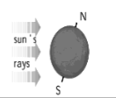

The diagram above shows which season in Australia?

(a) summer
(b) winter
(c) spring
(d) autumn

8. The different shapes of the moon as seen from Earth are called:

(a) stages.
(b) faces.
(c) phases.
(d) crescents.

9. Refer to the diagram below for the next question.

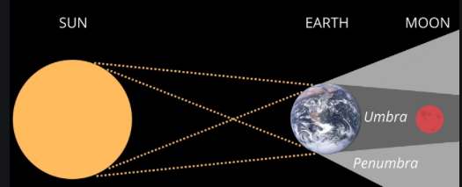

The diagram above shows the alignment of the Sun, Earth and Moon during:

(a) a solar eclipse.
(b) a lunar eclipse.
(c) a blue Moon phenomena.
(d) a new Moon phase.
10. A 'year' on Earth is 365 ¹/₄ days because:

(a) that's how long it takes the Sun to orbit the Earth.
(b) every fourth year is a leap year.
(c) it takes this amount of time for the Earth to orbit the Sun.
(d) this is the time it takes the Earth to spin on its axis.

11. The reason we don't see the stars during the day is:

(a) they are all on the other side of the Earth at this time.
(b) the stars can only be seen at the same time as the Moon.
(c) stars only reflect the Sun's light when it is dark.
(d) the Sun's light is too bright during the day for us to see them.

12. The moon doesn’t radiate (give off) any of its own light. Instead, light reflects off its surface, which allows us to see it.

(a) true
(b) false

13. Like the stars, we can only see the Moon at night.

(a) true
(b) false

14. The force that causes high and low tides on Earth is:

(a) gravity.
(b) friction.
(c) Moon rays.
(d) Moon magnetism.

15. A solar eclipse occurs when:

(a) the Earth is between the Sun and the Moon.
(b) the Moon is between the Earth and the Sun.
(c) the Sun is between the Moon and the Earth.
(d) the Sun cools down slightly for a few minutes.

16. The imaginary line around the middle of the Earth is called:

(a) the axis.
(b) the equator.
(c) line of longitude.
(d) the rotational pathway.

17. Refer to this diagram to answer the question below.

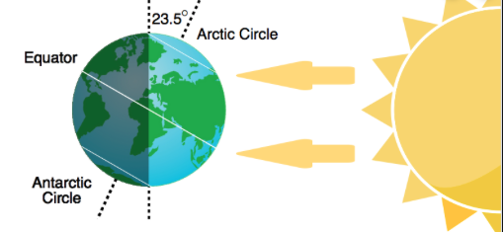

Approximately how many hours of sunlight does the Arctic Circle receive each day during summer?

(a) No sunlight. The Arctic Circle is in darkness at this time of the year.
(b) 24 hours. During summer, the Arctic Circle does not experience night at this time of the year.
(c) 12 hours. In summer, the days and nights are EXACTLY 12 hours long each.
(d) The same amount of sunlight as the Antarctic circle.

18. Refer to this diagram to answer the next TWO questions below.

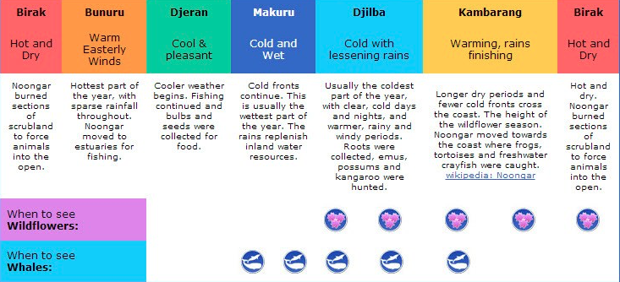

The Noongar season of Birak occurs during which months of the year?

(a) February - March
(b) August - September
(c) April - May
(d) December - January

19. What were the tell-tale signs to the Noongar people that one season was changing to another?

(a) They received a notification on their iPads.
(b) There were changes in the local plants and animal resources in line with changes in the weather.
(c) It got colder and wetter.
(d) The whales and wildflowers were visible.

20. Refer to the image below for the following TWO questions.
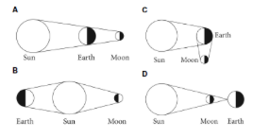

Which of the images above represents a solar eclipse?

(a) A
(b) B
(c) C
(d) D

21. Which of the images above is an IMPOSSIBLE situation?

(a) A
(b) B
(c) C
(d) D

Use the image below to answer the following TWO questions.

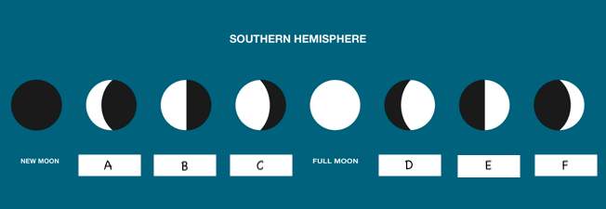

22. Which of the moon phases is the brightest and marks the transition from the waxing phase to the waning phase?

(a) New Moon
(b) Full Moon
(c) C
(d) D

23. The waning gibbous phase is represented by which image?

(a) A
(b) C
(c) D
(d) F

24. June 21 is the summer solstice in the northern hemisphere. When is the summer solstice in the southern hemisphere?

(a) December 1 (the first day of summer in Australia)
(b) June 21
(c) September 21
(d) December 21

25. What name do we give to the two days a year when daytime and night-time are of approximately equal duration all over the planet?

(a) New Year's Day and Mid-year's Day
(b) Equinox (Autumn and Spring)
(c) Solstice (Summer and Winter)
(d) None of the above - this never happens.

Short Answer Write the answer to the questions in the spaces provided.

1. Choose the correct definition for the term in the first column of the table below. Write the correct letter in the second column. (4 marks)

TERM | CORRECT LETTER | DEFINITION
Rotation |  | A: Describes the Earth's movement around the  Sun.
New moon |  | B: When the whole of the Moon's surface has  sunlight reflected from it.
Tides |  | C: When the Moon passes into the Earth's  shadow.
Lunar eclipse |  | D: An imaginary line through the Earth from the  north pole to the south pole.
Revolution |  | E: Causes the Earth to have night and day.
Full moon |  | F: When the Moon passes across the Sun.
Solar eclipse |  | G: When no light is reflected from the Moon.
Axis |  | H: Caused by the gravity of the Moon.

2. Sketch the shape of: (2 marks)

(a) a crescent moon

(b) a gibbous moon

3. Draw a diagram of a solar eclipse, showing the position of the Sun, Moon and Earth.
Include rays to show the path of the sunlight. (4 marks)

